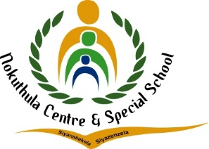


TEL: (010) 023 0609
E-MAIL: nokuthulasmh@mweb.co.za
NPO No: 001041
________________________________________________________
LESSON PLAN

Subject: Life Skills | Grade: 3 year 2 |  |  | Term: 4 |  |  | Week: 3-4
Topic: Products and Processes |  | Content: | Time allocation: 1 week |  |  | Date Started: |  | Date Completed:
Prior content knowledge | Lesson objectives: The learners must be able to:  - Identify that there are processes behind many everyday items we use.  - Identify how processes change from basic ingredients to things we use.  - Identify 5 items that we get from plants  - Identify 5 items that we get from earth  - Identify 5 items that we get from Animals |  |  |  | Vocabulary /Important word: |  |  |  | Teaching Strategies:  Demonstrate  Observation  Questions and Answers
Resources: | Teacher Activities  Discuss : From plants – process from cane to sugar Discuss : From earth – process from clay to brick |  |  |  | Learner Activities  Match the |  |  |  | Assessment Goal:  Assessment Strategy  Informal  Formal  Assessment tool: Rubric

Differentiation (Enrichment opportunities/addressing barriers) | Practical task
- Group 1:
- Group 2:
- Group3:
Teacher Reflection: | Name of Teacher:
HOD Input: | Name of HOD: Steven

